**Name:** V Venkata Sri Prasad

**Batch:** Data Engineering

**Date:** 23/02/2024 – (Day 26)

Topics:

1. What are Repos
2. How to connect the azure repos with local data with gitbash

Azure Repos:

Azure Repos is a version control service provided by Microsoft Azure, offering Git repositories for source code management. It integrates seamlessly with Azure DevOps, allowing teams to collaborate on projects efficiently. Azure Repos provides features like branching, pull requests, and code reviews to streamline development workflows. It offers unlimited private repositories, ensuring security and privacy for your codebase. Azure Repos supports both public and private projects, enabling flexibility for teams of any size.

Creating Repos links and storing data to local

Go to Azure Devops Organisation and select your project and click on repos:

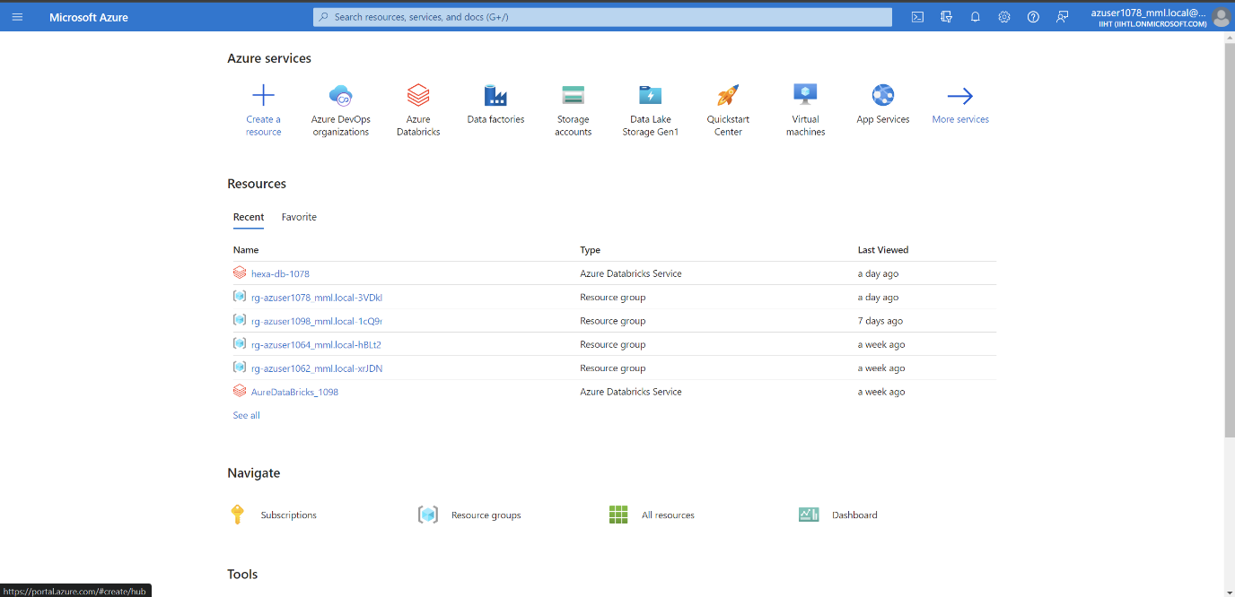

Open git bash and give the path to the specified link that you need the file to be stored. Copy your github link and write the command as shown here.

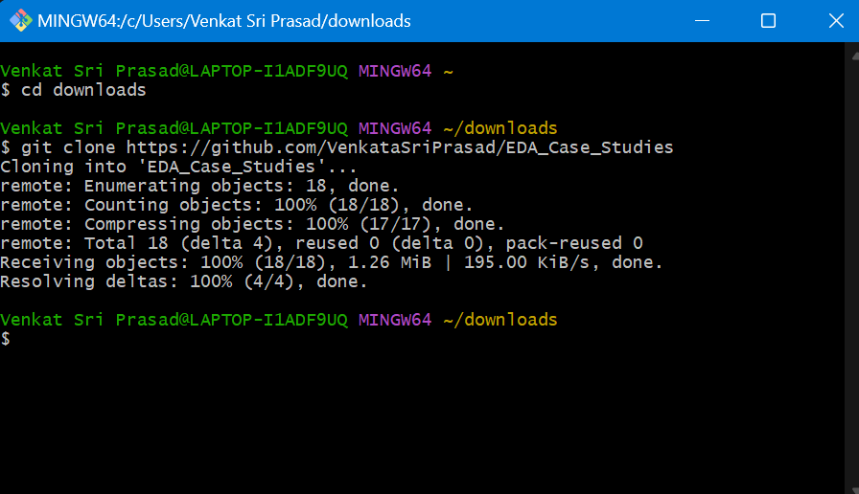

We can see the file is created

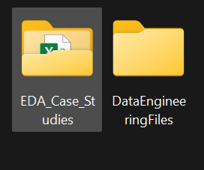

Now copy the azure git link and paste it in the git clone in git bash

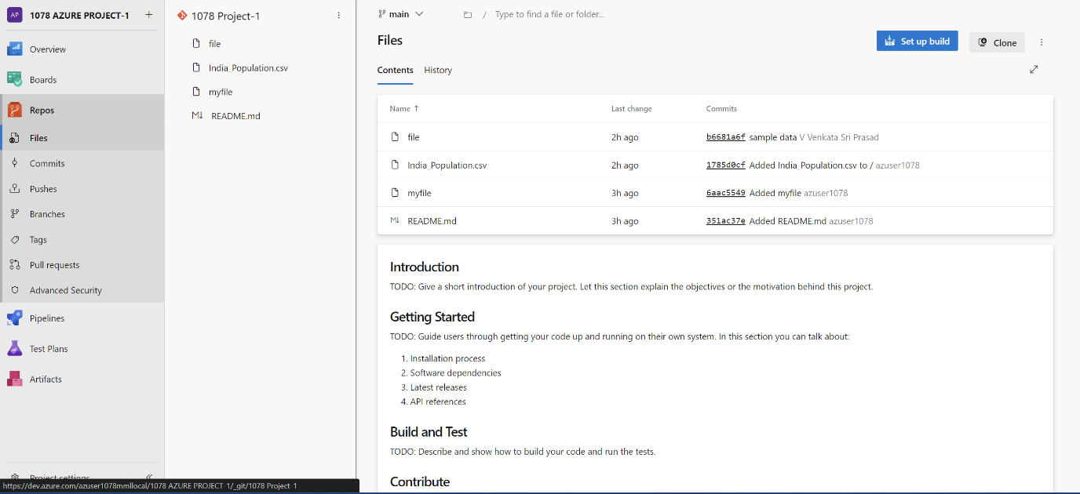

Follow these commands



So the file is created on azure repos

